User Manual for the Wave Ray Flux Program (Python Version)
This program is developed based on Rossby wave ray tracing theory in horizontally non-uniform basic flow fields (Li et al., 2012, 2015, 2019; Zhao et al., 2015, 2019). It aims to simulate and analyze the propagation paths of quasi-stationary Rossby waves within complex background flows that include meridional wind components. Additionally, it measures the magnitude and direction of wave activity using wave ray flux in the Li-Yang WRF system (Yang and Li, 2025).
Core Functionality:
- For a given background flow field, the program solves the Rossby wave dispersion relationship that includes meridional wind components.
- It calculates the group velocity and uses the fourth-order Runge-Kutta method to integrate the ray equations, tracking the trajectory of the energy disturbance.
- Based on these computations, the wave ray flux is obtained.
- The system is applicable for theoretical studies exploring Rossby wave propagation mechanisms and diagnosing excitation sources and remote responses in actual circulations. It serves as a valuable tool for researching various teleconnection patterns and energy upstream-downstream transmissions.
User Manual Contents:
- Explanation of wave ray program modules
- Example calculation
- How to use the wave ray program
- How to use the wave ray flux program
- References to relevant publications

Contribution Acknowledgments
- Wave Ray Program Development (Python): Yinan Yang, Professor Jianping Li, Dr. Yanjie Li, Dr. Sen Zhao, Ruipeng Sun
- Wave Ray Flux (Li-Yang WRF) Program Development (Python): Yinan Yang, Professor Jianping Li
- User Manual Compilation: Organized by Yang Yinan, with valuable guidance from Dr. Sen Zhao and Professor Jianping Li.
The Python-based wave ray tracing program was adapted from the Fortran version originally developed by Dr. Yanjie Li, Dr. Sen Zhao, and Prof. Jianping Li. Their work has provided essential reference value and guidance for the development of the present system. We extend our heartfelt appreciation for their pioneering contributions and the generous support they have provided throughout this process. In addition, Yifan Liu contributed to discussions during the development of the Python ray-tracing program, and many colleagues—including Linjie Wang, Mian Zhu, and Gongjun Zhang—offered constructive suggestions that greatly improved the Li-Yang WRF program.
The original Chinese documentation was translated into English (this document) with the assistance of the Pacific Northwest National Laboratory (PNNL) AI Incubator (GPT-4 from OpenAI), reviewed and edited by Koichi Sakaguchi at PNNL ,and further reviewed and approved by Yinan Yang.

Explanation of Wave Ray Program Modules
1. constants.py
- Defines constants and units for the system.
2. interpolation.py
- Implements bilinear interpolation on a spherical 2D field.
- Provides values of the basic flow field and its first, second, and third derivatives at any location.
- Supports flexibility across different resolutions to create a continuous space for subsequent processes such as Runge-Kutta integration, wavenumber calculations, and group velocity computations.
3. bs.py
- Performs preprocessing of the basic state (BS).
- Calculates derivatives of the background field and other essential variables (e.g., absolute vorticity ($q$) and its higher-order derivatives, $β_{m}$, among others).
4. wn.py
- Solves the Rossby wave dispersion relationship to determine meridional wavenumbers ($l$).
- Can calculate the stationary wavenumber (Hoskins & Ambrizzi, 1993), non-stationary wavenumber (Hoskins & Yang, 1996), and wave analysis with meridional basic airflow (Zhao et al., 2015).
- These analyses depend entirely on the basic airflow and provide significant insights into wave propagation under different climate conditions.
- Determines whether real roots exist among the three solutions and evaluates wave propagation and termination conditions.
5. wr.py
- Conducts Rossby wave ray tracing.
- Serves as the core computational module of the program.
- Solves the wave dispersion relationship and uses the fourth-order Runge-Kutta method for numerical integration.
- Outputs wave propagation paths, wavenumbers, group velocity, and amplitudes.
6. main_wr.py
- Acts as the primary entry point for executing the wave ray system.
- Designed for specific experimental scenarios with complete parameter settings, module calls, and computation flow management.
- Users can adjust parameters based on their research content.

7. Supplementary: Background Field Processing Using Spherical Harmonic Spectral Filtering (SHSF)
Introduction:
SHSF is a classical spectral analysis technique for spherical harmonic expansion, truncation, and reconstruction. It is commonly used to extract low-frequency components, filter noise, conduct scale analysis, or denoise and reconstruct meteorological variables (e.g., wind fields and geopotential height) on a sphere.
Steps:
- Expansion:
Decompose 2D grid data $f(θ, ϕ)$on the sphere into a sum of spherical harmonics:
$$\begin{aligned}f\left(θ,ϕ\right)=\sum_{l=0}^{L_{max}}{ }\sum_{m=-l}^{l}{ }a_{lm}Y_{lm}\left(θ,ϕ\right).\#\left(1\right)\end{aligned}$$
Here, $Y_{lm}$are spherical harmonics, and $a_{lm}$are expansion coefficients. Uses Driscoll & Healy (DH) sampling for complete spherical orthogonal sampling.
- Truncation:
Limits the spherical harmonic series to a maximum degree $l≤L_{cutoff}$, discarding higher-order terms (high-frequency information):
$$\begin{aligned}f_{trunc}\left(θ,ϕ\right)=\sum_{l=0}^{L_{cutoff}}{ }\sum_{m=-l}^{l}{ }a_{lm}Y_{lm}\left(θ,ϕ\right).\#\left(2\right)\end{aligned}$$
Retains large-scale, low-frequency components while removing noise or local disturbances.
- Reconstruction:
  - Synthesizes grid data using the truncated harmonic coefficients to convert from spectral space to physical space.

Spherical Harmonic Processing References:
- Relevant Code: Zhao Sen’s GitHub repository: xspharm
- Python Dependency: Utilize pyshtools for spherical harmonic spectral filtering (e.g., through SHSF.py).
- NCL Implementation: Use functions shaec, tri_trunc, and shsec, which correspond to the three steps above.

2. Example Calculation
The Great Circle theory is often regarded as an almost perfect theoretical framework for the propagation of spherical Rossby waves (Hoskins and Karoly 1981; Karoly 1983). Using this theory as an example, the results of running this program are shown in Figure 1.
The background field (file: ideal basic flow.nc, provided by Yifan Liu), the main calculation program (the Great Circle calu.py), and the plotting code (the Great Circle plot.py) have been uploaded to the repository for readers to try.
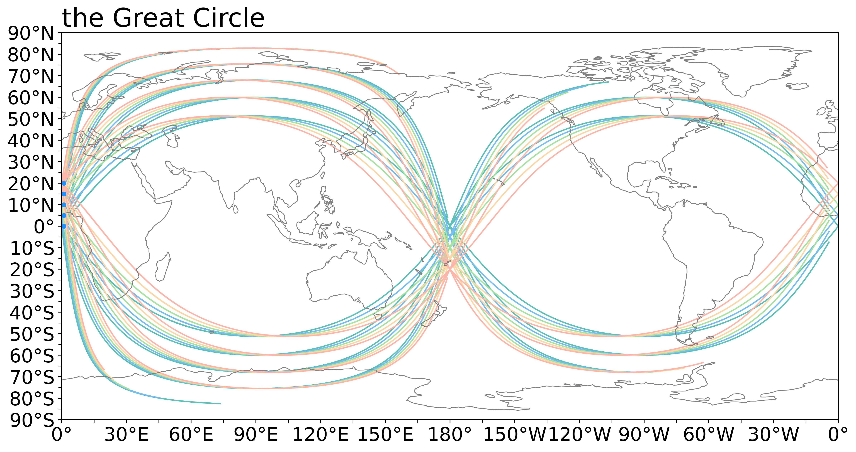

Figure 1: Wave ray tracing experiment based on ideal basic flow, with initial zonal wavenumbers of 1–5 and a propagation time of 30 days. The wave source is set at 0° longitude, with latitude ranging from 0° to 20°N at a resolution of 5°.

3. How to use the wave ray program
Set parameters in the main program main_wr.py:
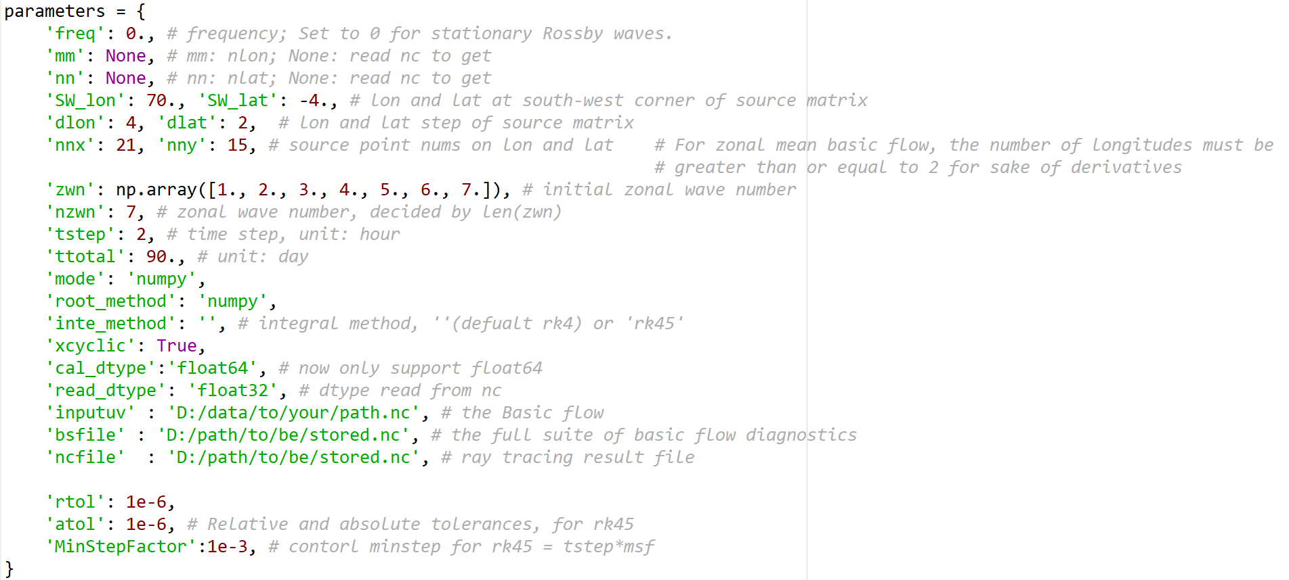

Parameter Settings in main_wr.py
- SW_lon, SW_lat: Starting position of the wave source matrix (southwest corner).
- dlon, dlat: Resolution of the wave source in the zonal (longitude) and meridional (latitude) direction.
- nnx, nny: Number of wave sources in the zonal and meridional directions, respectively.
- zwn: Initial zonal wavenumber.
- tstep: Time step; ttotal: Total duration.
- inputuv: Input background field. Requirements:
  - The provided .nc file must contain 'u', 'v', 'lat', and 'lon' variables.
  - Variables 'lat', 'latitude', 'Lat', and 'Latitude' are all accepted for latitude; the same applies to longitude.
  - u, v must have shapes of (lat, lon).
  - Longitude (lon) must strictly range from 0° to 360°.
  - Latitude (lat) must start at -90° (90°S).
- bsfile: Output file for all diagnostic quantities of the background field.
- ncfile: Output file for wave ray computation results, including:
  - rlon: Longitude variable for the wave ray path.
  - rlat: Latitude variable for the wave ray path.
  - rzwn: Zonal wavenumber variable for the wave ray.
  - rmwn: Meridional wavenumber variable for the wave ray.
  - ramp: Wave amplitude variable along the wave ray.
  - rug: Zonal group velocity variable along the wave ray.
  - rvg: Meridional group velocity variable along the wave ray.

4. How to use the wave ray flux program
Based on the Rossby wave ray tracing theory in horizontally non-uniform basic flow fields, Yang and Li (2025) introduced a new concept: the horizontal Rossby wave ray flux (Li-Yang WRF). This concept is used to diagnose the propagation paths, local activity levels, and propagation directions of Rossby waves. Readers are encouraged to refer to the specific literature for a detailed understanding of the theory and methods.
The program consists of three function files (Fun1_threshold, Fun2_region_threshold, Fun3_WRF_calculate) and one main program (WRF_universal). Their functionalities are as follows:
- Fun1_threshold:
Extracts variables from wave-ray calculation results, sets truncation velocity thresholds, and removes abnormal wavenumber data (the latter two are optional parameters).
- Fun2_region_threshold:
Selects wave rays passing through the desired target region.
- Fun3_WRF_calculate:
Calculates the Li-Yang WRF. As the program evolves, it can calculate additional variables such as the average propagation time, average speed, and wave sources for wave rays passing through target areas, making it a powerful tool for diagnosing Rossby wave activity.
All these operations are performed in the main program WRF_universal.

Notes:
- The program offers flexibility tailored to specific research needs. For instance:
  - Some users may focus on waves propagating eastward through the eastern hemisphere to the western hemisphere.
  - Others may examine waves traveling eastward through the western hemisphere to the eastern hemisphere.
  - Similarly, users may investigate westward-propagating waves across hemispheres.
Such diverse requirements pose challenges for the planar visualization of WRF results. To meet these demands, the Li-Yang WRF calculation scope covers three longitude circles (from -360° to 720°), ensuring compatibility with varying research interests.
- Changes in latitude do not require consideration of these scenarios due to limitations imposed by the basic flow.

5. References to relevant publications
Rossby Wave Rays and the Li-Yang Wave Ray Flux
- Li, Y. J. and J. P. Li, 2012:
Propagation of planetary waves in the horizontal non-uniform basic flow. Chin. J. Geophys. (in Chinese), 55, 361–371.
- Li, Y. J., J. P. Li, F.-F. Jin, and S. Zhao, 2015:
Interhemispheric propagation of stationary Rossby waves in a horizontally nonuniform background flow. J. Atmospheric Sci., 72, 3233–3256, https://doi.org/10.1175/JAS-D-14-0239.1.
- Li, Y. J., J. Feng, J. P. Li, and A. Hu, 2019:
Equatorial windows and barriers for stationary Rossby wave propagation. J. Clim., 32, 6117–6135, https://doi.org/10.1175/JCLI-D-18-0722.1.
- Yang, Y. N. and J. P. Li, 2025:
Novel monsoon indices based on vector projection and directed angle for measuring the East Asian summer monsoon. Clim. Dyn., 63, 210, https://doi.org/10.1007/s00382-025-07696-7.
- Zhao, S., J. P. Li, and Y. J. Li, 2015:
Dynamics of an interhemispheric teleconnection across the critical latitude through a southerly duct during boreal winter. J. Clim., 28, 7437–7456, https://doi.org/10.1175/JCLI-D-14-00425.1.
- Zhao, S., J. P. Li, Y. J. Li, F.-F. Jin, and J. Zheng, 2019:
Interhemispheric influence of Indo-Pacific convection oscillation on southern hemisphere rainfall through southward propagation of Rossby waves. Clim. Dyn., 52, 3203–3221, https://doi.org/10.1007/s00382-018-4324-y.

Classic References Mentioned in the Documentation
- Hoskins, B. J. and D. J. Karoly, 1981:
The steady linear response of a spherical atmosphere to thermal and orographic forcing. J. Atmos. Sci., 38, 1179–1196, https://doi.org/10.1175/1520-0469(1981)038%3c1179:TSLROA%3e2.0.CO;2.
- Hoskins, B. J. and T. Ambrizzi, 1993:
Rossby wave propagation on a realistic longitudinally varying flow. J. Atmos. Sci., 50, 1661–1671, https://doi.org/10.1175/1520-0469(1993)050<1661:rwpoar>2.0.co;2.
- Karoly, D. J., 1983:
Rossby wave propagation in a barotropic atmosphere. Dyn. Atmos. Oceans., 7, 111–125, https://doi.org/10.1016/0377-0265(83)90013-1.
- Yang, G. Y. and B. J. Hoskins, 1996:
Propagation of Rossby waves of nonzero frequency. J. Atmos. Sci., 53, 2365–2378, https://doi.org/10.1175/1520-0469(1996)053<2365:porwon>2.0.co;2.

